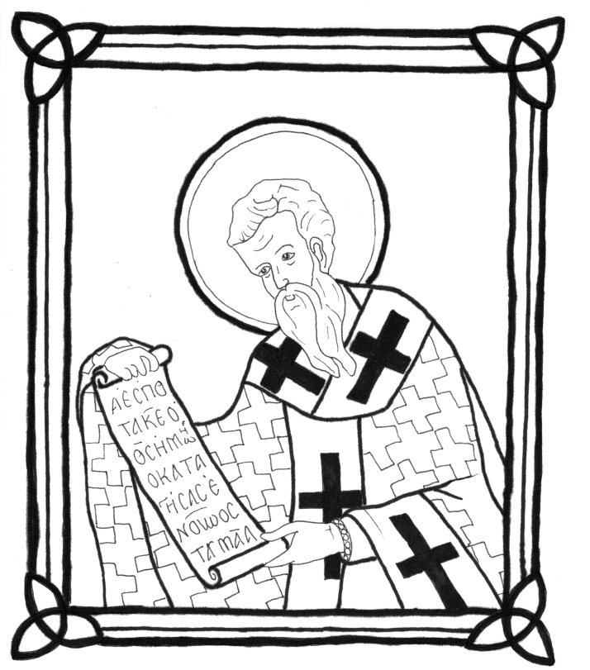
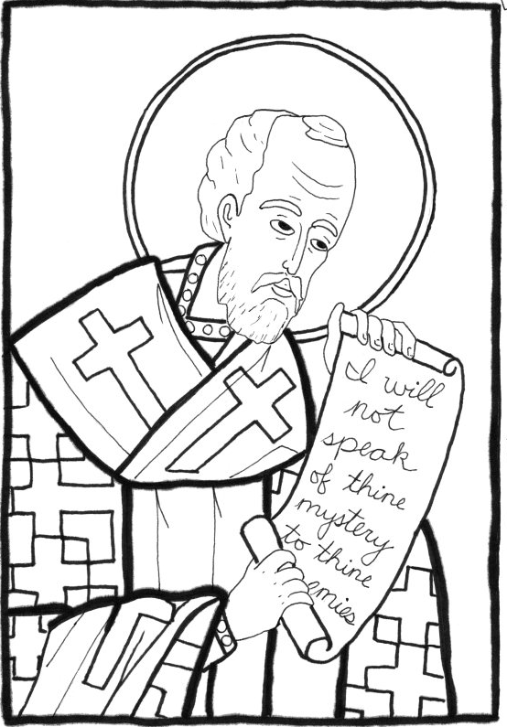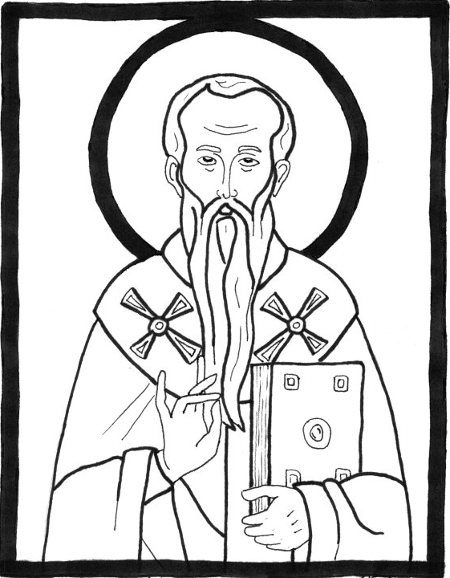
St John Chrysostom St Basil the Great St Gregory the Theologian

The Three Holy Hierarchs
These three men of the Church remind us to stand firm in the faith together.

